￥

Class No. Name .

Make as many words as you can with

|  |  |  |
| --- | --- | --- |
|  |  |  |
|  |  |  |
|  |  |  |
|  |  |  |
|  |  |  |

**What’s missing?**

|  |  |
| --- | --- |
| **Across** **1.** S_nt_ **3.** w_sh **5.** pr_sen_ | **Down** **1.** sno_ma_ **2.** l_gh_s **4.** _oli_ay **6.** _ree |

**Christmas Traditions in Canada**

|  |  |  |
| --- | --- | --- |
| **advent c .** | **d .** | **p .** |
| **d .** | **family g .** | **t .** |
| **e .** | **church s .** | **p .** |

**Find the Difference**

**A**

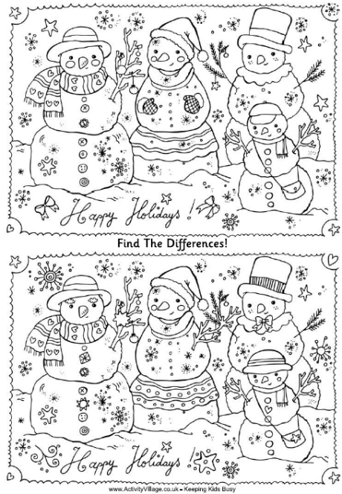

**B**



|  |  |  |  |  |  |  |  |  |  |  |
| --- | --- | --- | --- | --- | --- | --- | --- | --- | --- | --- |
|  | 1 | 2 | 3 | 4 | 5 | 6 | 7 | 8 | 9 | 10 |
| A | R | W | I | H | J | P | E | A | C | E |
| B | G | B | K | D | V | X | W | H | C | X |
| C | A | N | S | E | R | V | I | C | E | H |
| D | T | R | M | C | G | B | W | A | R | V |
| E | H | G | T | O | P | D | R | L | C | R |
| F | E | T | U | R | K | E | Y | E | T | H |
| G | R | H | I | A | E | G | G | N | O | G |
| H | I | P | R | T | L | S | V | D | M | A |
| I | N | G | M | I | F | H | F | A | S | B |
| J | G | S | N | O | C | E | B | R | E | A |
| K | L | D | O | N | A | T | I | O | N | X |
| L | H | S | R | S | L | P | Q | X | F | I |
| M | N | B | P | A | R | A | D | E | B | T |
| N | W | N | G | E | P | R | L | J | X | K |

|  |  |  |  |  |  |  |  |  |  |
| --- | --- | --- | --- | --- | --- | --- | --- | --- | --- |
|  |  |  |  |  | 1 |  |  |  |  |
|  |  |  | 2 |  |  |  |  |  |  |
|  |  |  |  |  |  |  |  |  |  |
|  |  |  |  |  | 3 |  |  | 4 |  |
|  |  |  |  |  |  |  |  |  |  |
|  |  |  |  |  |  |  |  |  |  |
| 5 |  |  |  |  |  | 6 |  |  |  |
|  |  |  |  |  |  |  |  |  |  |
|  |  |  |  |  |  |  |  |  |  |
|  |  |  |  |  |  |  |  |  |  |